GOV TRAVEL CARD APPLICATION PACKET

Attached is the application (fill out Part 1 only), statement of understanding, online training certificate memo and card use info. The Bank of America application form must have the applicant’s name entered correctly, which is their first name, middle initial and then last name, not last name first. The applicant must read the agreement section of the Bank of America application before initialing (No check mark or “X”) either “A” or “B” in part 1. The DD2883, Credit Worthiness Evaluation, must be submitted only if the applicant does not authorize the bank to obtain credit reports by initialing paragraph "b" in the agreement section on the Bank of America application. The Commander/Supervisor must also sign the DD2883 in box #24 only. The applicant will be issued a restricted card.

A restricted card is an account with the credit limit of $2000 and ATM cash advance limit of $250. The restricted account is determined by the applicants’ credit rating or if they do not authorize the bank to obtain credit reports by initialing “b” in the agreement section of the application. If the cardholder has a restricted account they must not only call Bank of America to verify that they received the card, they must call the APC (SSG Merwin) to activate the card. All cardholders must call the bank as soon as they receive the card, do not wait until they need to use it.

If the applicant requests the card expedited, they must check the expedited box. The card will be delivered by FEDEX (no weekend or holiday deliveries) within 4-5 days after processing. There will be a $20 expedited fee charged to the card and they must enter the charge on their travel voucher for reimbursement. There must be someone at the address to sign for it or FEDEX will not deliver the card. If not expedited, the card will be sent regular mail for delivery in 7-10 business days after processing.

The Commander/Supervisor must sign the application (on line below the applicant’s signature), statement of understanding and DD Form 2883.

The packet must be sent thru their MACOM/Directorate Program Coordinator for the Gov Card.
The application must be legible or it will be rejected. The application and DD2883 is in fillable format on the computer.
The application packet will not be accepted by fax. Send it to the address below.
The use of the card is not authorized while on State Active Duty orders

It is mandatory that the charges on the card are split-disbursed to the card account on the DD Form 1351-2, travel voucher in block #1. Enter the amount charged, not “ALL” or leave blank. Accrual travel vouchers must be submitted every 15 days for TDY orders in duration of 30 days or more to avoid card account delinquency.

new app. 10-20-06

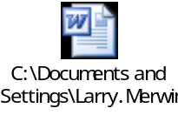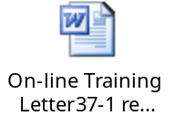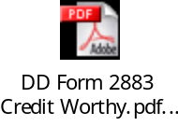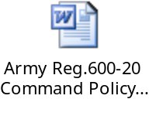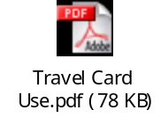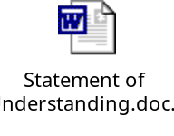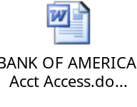
The application packet must arrive in this office 10-14 business days before the start of TDY.

SSG Larry Merwin
APC, Gov Travel Card
DMNA
MNPF-QA, NYARNG
330 Old Niskayuna Road
Latham, NY 12110
Phone (518) 786-4636 DSN 489-4636
Fax (518) 786-4708

Larry.Merwin@ny.ngb.army.mil <mailto:Larry.Merwin@ny.ngb.army.mil>

