TRADITIONAL GUARD OFFICER VACANCY ANNOUNCEMENT
109 AIRLIFT WING  1 AIR NATIONAL GUARD RD, SCOTIA, NY 12302-9752 | ANNOUNCEMENT#: | 20-08
 | OPENING DATE: | 27 May 2020
 | CLOSING DATE: | 27 June 2020
UNIT: 109th Force Support Squadron | AFSC: 38F3
MAX AVAILABLE GRADE:  Maj/O-4 | AREA OF CONSIDERATION: Nationwide  All candidates may apply who meet the basic qualification for this position and who are eligible for membership in the NYANG.
Appoint as 2LT - New Commissioning Opportunity

POSITION TITLE: Personnel Officer

SPECIALTY SUMMARY: (As outlined in AFI 36-2101 and AFMAN 36-2032)

Define, develop, shape, sustain, and deliver mission-ready Airmen across the Total Force. Responsibilities include defining Air Force Manpower and Organization Requirements, managing Human Resources, managing and providing Education and Training Requirements, regenerating Airmen, feeding Airmen, developing Human Capital Strategies, applying Laws and Policies, compensating Airmen, providing Force Readiness and Quality of Service Programs, and serves as senior staff advisor to commanders. Related DoD Occupational Group: 150000, 156000, 157000, 270200, 270300, 271400, 280500.

MINIMUM QUALIFICATIONS:

Must meet the minimum requirements as outlined in AFMAN 36-2032.

SPECIALTY QUALIFICATIONS

KNOWLEDGE:

- Knowledge of the following core competencies is mandatory: Force Development, Career Development, Force Management, Civilian Employee Management, Requirements Determination, Organization Principles, Performance Management, Manpower Resource Allocation, Customer Support, Readiness, Food Operations, Fitness Operations, Lodging Operations, Recreation, Resource Management, Mortuary Affairs, Casualty, SAPR, and Quality of Service Programs.

EDUCATION:

- For entry education requirements see Appendix A, 38F CIP Education Matrix provided below.
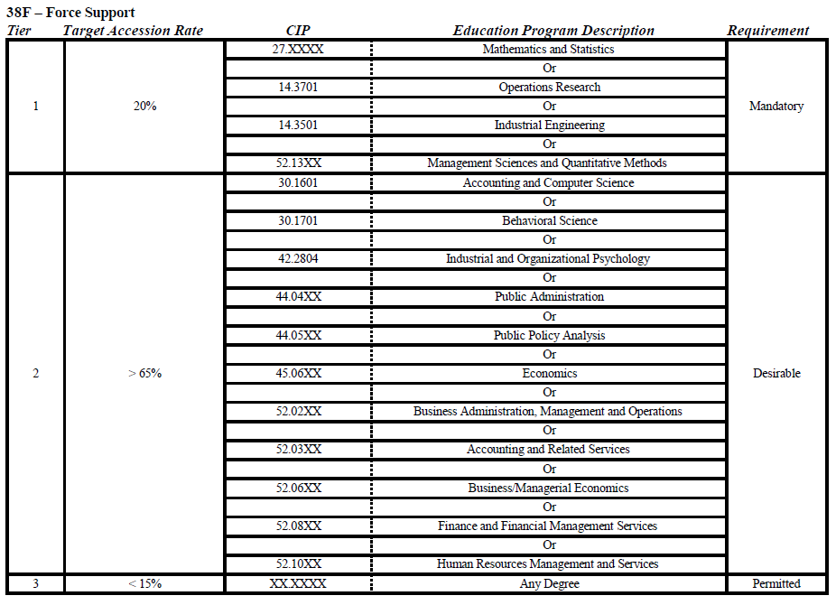

TRAINING: The following are mandatory as indicated:

- For award of AFSC 38F3, completion of Force Support Officer Initial Skills Training (IST) Course including Officer Field Education (OFE) is mandatory. A waiver from the CFM is required if any portion of IST is not completed. A minimum of 24 months of experience is also mandatory. In addition, within 24 months of graduating Force Support Officer IST, an officer must also complete the Follow-On Unit Training (FOUT) outlined in the Career Field Education and Training Plan (CFETP), Basic KSA Course, and Basic Contingency Course.

- All requirements must be certified by the FSS commander or senior career field leader assigned to the organization. A waiver from the CFM is required if the FOUT or other tasks cannot be completed within the 24-month period. ANG and AFR personnel will coordinate waivers with their component CFM and the RegAF CFM.

EXPERIENCE: The following experience is required for award of the AFSC indicated:

- For award of AFSC 38F3, a minimum of 24 months of experience is mandatory

DUTIES AND RESPONSIBILITIES:

- Formulate personnel plans and programs and develop policy to guide their implementation and execution. Translates program policy into directives, publications, and training manuals.

- Participate in total force adaptive planning and execution in support of combatant commanders from peacetime through mobilization, contingency operations and demobilization. Access manpower, personnel, and equipment availability for UTC posturing and management.

- Develop, control, program and allocate manpower resources in support of the Air Force planning, programming, budgeting and execution process. Analyze and determine force composition.

- Determine Total Force manpower requirements across the spectrum of Air Force capabilities. Employ industrial and management engineering methodologies to develop manpower determinants and standards. Manage allocation of military and civilian resources through execution and management of the UMD. Conduct management advisory studies.

- Develop, test, evaluate, and maintain Air Force recognized organization structure. Analyze and process organization change actions to activate, inactivate, redesignate, and reorganize unit structures.

- Administer Air Force performance management and productivity programs. Assess and document organizational performance. Advise on process improvement, best practices and recognizes optimal performance.

- Oversee and conduct strategic sourcing studies.

- Develop and execute the full spectrum of total force personnel programs to accomplish accession planning and processing, classification and utilization, promotion, recognition, evaluation, reenlistment, assignment action, retraining, retirement, disciplinary, force development and force shaping programs.

- Establish Air Force education and training policy requirements. Manage programs to include developmental education, voluntary education, advanced academic education, promotion testing, and libraries.

- Manages equal opportunity and sexual assault prevention and response programs.

- Leads and supervises contingency training and operations with an emphasis on specific capabilities and processes focused on expeditionary organizations and command relationships, feeding operations, lodgment of forces, mortuary affairs, casualty reporting, force accountability, fitness, recreation, learning resource centers, protocol, and NAF resale operations for both peace and wartime operations.

- Develop and administer fitness programs designed to keep the Total Force fit and regenerate Airman and families.

- Develop recreational programs to include sports management, tournaments, and special entertainment designed to regenerate the Total Force.

- Lead Quality of Service programs and business operations. Establish and maintain sound appropriated and nonappropriated fund financial and corporate standards with internal controls. Establish short- and long-range plans to include growth and facility/equipment improvement and/or replacement.

- Develop, administer, and monitor Airman and Family Programs ensuring compliance with policies and standards.

- Institute customer service practices designed to meet the needs of commanders, supervisors and the force at large in peacetime and wartime operations.

OTHER QUALIFICATIONS:

- No record of disciplinary action (Letter of Reprimand [LOR] or Article 15) for: 3.5.2.1. Failure to exercise sound leadership principles, especially with respect to morale or welfare of subordinates; or

- Engaging in an unprofessional or inappropriate relationship as defined in AFI 36-2909, Professional and Unprofessional Relationships; or documented failures (LOA, LOR or Article 15); or

- Taking or failing to take action in situations, thereby exhibiting a lack of integrity; or

- A violation of Article 107, false official statements, Uniform Code of Military Justice (UCMJ).
- No convictions by a general, special or summary courts-martial.

- No Unfavorable Information File.

- Never been convicted by a civilian court of a Category 1, 2, or 3 offense, nor exceeded the accepted number of Category 4 offenses. Category 3 and 4 traffic offenses alone are not disqualifying. NOTE: Categories of offenses are described and listed in AFMAN 36-2032, Regular Air Force and Special Category Accessions, Uniform Guide List of Typical Offenses.

- No recorded evidence of substance abuse, emotional instability, personality disorder, or other unresolved mental health problems.

OBIS: An Officer Screening and Interviewing Board (OSIB) is scheduled to convene to interview all qualified applicants. Applicants will be informed in writing, or telephonically of date and time to appear.

APPLICATION PROCEDURES:
All applicants will prepare and forward the following no later than close of business on closing date either by mail or email:
- Cover Letter
- Resume
- One copy of the AF Form 24 (Application of Appointment as Reserve of the Air Force or USAF Without Component)
- Current Official College Transcripts (sealed envelope in application, or mailed directly to the address below)
- DD Form 2807-2 (Medical Prescreen of Medical History Report) and final disposition paperwork for any offenses.

All PRIOR SERVICE applicants will prepare and attach the following in addition to the above requirements no later than close of business on closing date either by mail or email:
- A Record of Separation/Discharge from the US Armed Forces (if applicable)
- vMPF records review RIP
- Most current Physical Fitness Evaluation Report (if applicable).

MAIL RESUME’S TO:
109TH FSS
1 Air National Guard Road
Scotia, NY 12302-9752
ATTN: TSgt Kaitlyn L. Simmons

TO APPLY PLEASE SEND APPLICATIONS TO: kaitlyn.l.simmons.mil@mail.mil; PLEASE LIMIT ATTACHMENTS TO UNDER THREE

For assistance with sending in an application, please contact TSgt Kaitlyn L. Simmons:
Phone 518-344-2095

For questions regarding the job or details on position requirements, please call (518) 344-2456 to speak with the 109th Airlift Wing Recruiting Office

DISTRIBUTION:
1 – 109 FSS/FMPS

