TRADITIONAL GUARD OFFICER VACANCY ANNOUNCEMENT
109 AIRLIFT WING  1 AIR NATIONAL GUARD RD, SCOTIA, NY 12302-9752 | ANNOUNCEMENT#: | 21-01
 | OPENING DATE: | 8 Oct 2020
 | CLOSING DATE: | 7 Nov 2020
UNIT: 109th Maintenance Operations Flight | AFSC: 21A3
MAX AVAILABLE GRADE:  Maj/O-4 | AREA OF CONSIDERATION: Statewide  All candidates may apply who meet the basic qualification for this position and who are eligible for membership in the NYANG.
POSITION TITLE: Flight Commander

SPECIALTY SUMMARY: (As outlined in AFI 36-2101 and AF Officer Classification Directory)
Leads, trains, and equips personnel supporting aerospace equipment sustainment and operations. Manages maintenance and modification of aircraft and associated equipment. Administers aircraft maintenance programs and resources. Directs aircraft maintenance production, staff activity, and related materiel programs. Assesses unit capability and advises senior leadership. Related DoD Occupational Groups: 240400.

MINIMUM QUALIFICATIONS:
Must meet the minimum requirements as outlined in AFI 36-2005 and ANGI 36-2005.

SPECIALTY QUALIFICATIONS:

KNOWLEDGE:
The following knowledge is mandatory for award of the AFSC: maintenance and personnel management procedures, and organizational and mission requirements; capabilities, limitations, and basic operating principles of aircraft systems and components; theory of flight and airframe construction; life cycle sustainment, quality assurance; supply, transportation, logistics plans, contracting, flying operations, munitions, and other unit operations related to aircraft maintenance units.

EDUCATION:
For entry education requirements see Appendix A, 21A CIP Education Matrix.
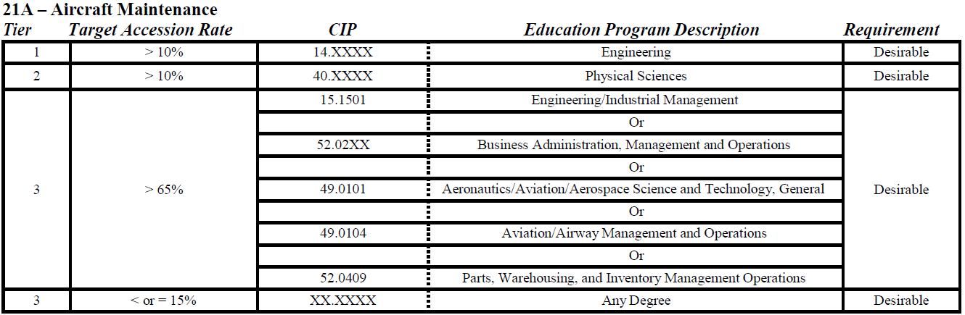

TRAINING:
For award of the 21A3, completion of a formal AETC entry-level training course; minimum of 24 months assigned to a 21A position (Group Commanders may extend this requirement) and completion of the education and training requirements specified in the Aircraft Maintenance Officer Training Task List.

EXPERIENCE:
For award of AFSC 21A3, a minimum of 24 months of experience managing aircraft maintenance activities is mandatory.

The following are mandatory for entry, award, and retention of this AFSC:

No record of conviction by a civilian court for offenses involving larceny, robbery, wrongful appropriation, burglary, or fraud.

Never received non-judicial punishment under the Uniform Code of Military Justice (UCMJ) for offenses involving acts of larceny, wrongful appropriation, robbery, burglary or fraud as defined in UCMJ Articles 121, 122, 129, and 132 or never been convicted by military courts-martial for these same offenses.

DUTIES AND RESPONSIBILITIES:
Directs aircraft maintenance mission generation and repair network activities. Maintains workforce discipline and responds to personnel issues while balancing workforce availability and skill levels with operational requirements. Works with functional managers to develop, formulate, and manage fiscal resources. Instills maintenance discipline, security awareness and force protection concepts. Ensures accuracy of documentation, i.e. aircraft forms and automated systems. Ensures adherence to technical data, policy, procedures, and safe maintenance practices.

Develops, coordinates, and executes flying and maintenance schedules. Manages aircraft configuration; daily aircraft servicing, weapons loading, launch, recovery, and repair; periodic aircraft maintenance inspections; and flight line safety and foreign object damage (FOD) prevention and dropped object programs (DOP). Manages overall aircraft fleet health and ensures aircraft availability to execute mission requirements. Analyzes aircraft maintenance indicators to identify trends and initiates corrective actions.

Directs maintenance activities that may include aircraft propulsion, pneudraulics, egress, fuel systems, electro-environmental, Precision Measurement Equipment Laboratory (PMEL) and avionics systems. Also may include management of aerospace ground equipment, structural repair, low-observable repair, corrosion control, machine, welding, inspection, aero-repair, crash, damaged, disabled aircraft recovery, non-destructive inspection, and off-equipment munitions and armament suspension equipment.

Manages quality assurance, maintenance training, budget and resource management, analysis, facilities, shared resources to include end-of-runway and weapons load training. Manages plans and programs, modifications, and modernizations requirements.

Formulates maintenance plans and policies to meet unit tasking. Assesses unit maintenance capability in support of combat related operational plans and provides inputs for capability assessments for each plan. Defines aircraft maintenance procedures and requirements in response to emergency or contingency situations.

Coordinates core logistics requirements supporting aircraft maintenance operations. Establishes support requirements for supply requisition, repair cycle, delivery, combat support, ground and aerial port transportation, base support plans, and munitions requirements.

Directs and manages wholesale logistics life cycle sustainment support. Coordinates production schedules to include induction and selling systems. Defines technical problems and economic factors related to research and development, and system operational data to evaluate programs, assess trends, and identify improvements and deficiencies. Manages weapons system programs, funding of depot maintenance workloads, and transportation distribution systems. Manages logistics tests and evaluation on new acquisition programs and aircraft modifications.

OTHER QUALIFICATIONS:
No record of disciplinary action (Letter of Reprimand [LOR] or Article 15) for: 3.5.2.1. Failure to exercise sound leadership principles, especially with respect to morale or welfare of subordinates; or

Engaging in an unprofessional or inappropriate relationship as defined in AFI 36-2909, Professional and Unprofessional Relationships; or documented failures (LOA, LOR or Article 15); or

Taking or failing to take action in situations, thereby exhibiting a lack of integrity; or
A violation of Article 107, false official statements, Uniform Code of Military Justice (UCMJ).

No convictions by a general, special or summary courts-martial.

No Unfavorable Information File.

Never been convicted by a civilian court of a Category 1, 2, or 3 offense, nor exceeded the accepted number of Category 4 offenses. Category 3 and 4 traffic offenses alone are not disqualifying. NOTE: Categories of offenses are described and listed in AFI 36-2002, Regular Air Force and Special Category Accessions, Uniform Guide List of Typical Offenses.

No recorded evidence of substance abuse, emotional instability, personality disorder, or other unresolved mental health problems.

OBIS: An Officer Screening and Interviewing Board (OSIB) is scheduled to convene to interview all qualified applicants. Applicants will be informed in writing, or telephonically of date and time to appear.

APPLICATION PROCEDURES:
All applicants will prepare and forward the following no later than close of business on closing date either by email:
- Cover Letter
- Resume
- Copy of Current Official College Transcripts
- AFOQT Scorecard
- A Record of Separation/Discharge from the US Armed Forces (if applicable)
- A recent vMPF records review RIP
- Most current Physical Fitness Evaluation Report (if applicable).

TO APPLY PLEASE EMAIL APPLICATIONS TO: kaitlyn.simmons.3@us.af.mil; PLEASE LIMIT ATTACHMENTS TO UNDER THREE

For assistance with sending in an application, please contact:
TSgt Kaitlyn L. Simmons
Phone: (518)344-2095

DISTRIBUTION:
1 – 109 FSS/FMPS

