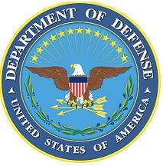
DEPARTMENT OF THE AIR FORCE

HEADQUARTERS 107th ATTACK WING
NIAGARA FALLS NY

ANNOUNCEMENT NAME: PUBLIC HEALTH OFFICER NF 24-14

OPENING DATE: 22 May 2024 CLOSING DATE: Until Filled

POSITION TITLE: PUBLIC HEALTH OFFICER

LOCATION: 107TH ATKW NIAGARA FALLS IAP, NIAGARA FALLS, NY 14304

1 POSITION AVAILABLE

AUTH GRADE: LTCOL (Subject to Control Grade Availability)

AFSC: 43H SALARY: IAW Current Rank & Active Duty Pay Documents

AREA OF CONSIDERATION: NATIONWIDE

TO APPLY EMAIL APPLICATIONS TO THE FOLLOWING:
MICHAEL.OWCZARCZAK@US.AF.MIL
STASHA.PERITORE.1@US.AF.MIL
SUBJECT LINE: PUBLIC HEALTH OFFICER NF 24-14

APPLICATION CONTENTS:
AF Form 24
Current PT
Most Recent vMPF records review RIP
DD214s/NGB22s/Separation orders if applicable

SELECTING OFFICIAL: COL JAN CARLSON

For more information or questions regarding this career field, please contact TSgt Thomas Viau at 716-236-2428 or by e-mail at Thomas.viau.2@us.af.mil .

