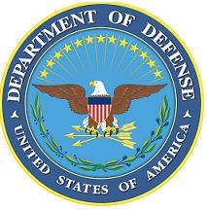DEPARTMENT OF THE AIR FORCE

HEADQUARTERS 107th ATTACK WING

NIAGARA FALLS NY

**ANNOUNCEMENT NAME: SECURITY FORCES OFFICER NF 25-3**

**OPENING DATE:** 04-DEC-2024 **CLOSING DATE:** 03-FEB-2025

**POSITION TITLE:** SECURITY FORCES OFFICER

**LOCATION:** 107th ATKW/ SFS Niagara Falls, New York

**1** POSITION AVAILABLE

**AUTH GRADE:** A NEW COMMISSIONING OPPORTUNITY; O-3 / CAPT **DSG POSITION**

**AFSC:** **31P**

**AREA OF CONSIDERATION:** Nationwide, State, Unit

**TO APPLY EMAIL APPLICATIONS TO THE FOLLOWING:**

[JORDAN.HALEY.7@US.AF.MIL](mailto:JORDAN.HALEY.7@US.AF.MIL)

[STASHA.PERITORE.1@US.AF.MIL](mailto:STASHA.PERITORE.1@US.AF.MIL)

SUBJECT LINE: **SECURITY FORCES OFFICER NF 25-3**

**APPLICATION CONTENTS:**

Required attachments: AF Form 24, Current PT, Resume, RIP Proof of Educational Requirements and Official Transcripts

**SELECTING OFFICIAL:** Capt. Kelli Fitch