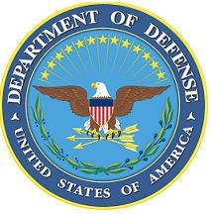DEPARTMENT OF THE AIR FORCE

HEADQUARTERS 107th ATTACK WING

NIAGARA FALLS NY

**ANNOUNCEMENT NAME: INSPECTIONS COORDINATOR NF 25-09**

**OPENING DATE:** 27-MAY-2025 **CLOSING DATE:** 15-AUG-2025

**POSITION TITLE:** Inspections Coordinator

**LOCATION:** 107th ATKW Niagara Falls, New York

**1** POSITION AVAILABLE

**AUTH GRADE:**E6/E7

**AFSC:** **8I100**

**AREA OF CONSIDERATION:** Wing

**TO APPLY EMAIL APPLICATIONS TO THE FOLLOWING:**

107FSS.Force.Management@us.af.mil

**SUBJECT LINE: INSPECTIONS COORDINATOR NF 25-09**

**APPLICATION CONTENTS:**

Letter of Recommendation from Commander

Official Military Bio

Must be a minimum grade of E6 and possess a 7-level AFSC

No UIF, civil convictions or an open IG investigation

**SELECTING OFFICIAL:** SMSgt Blamowski