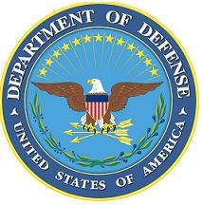DEPARTMENT OF THE AIR FORCE

HEADQUARTERS 107th ATTACK WING

NIAGARA FALLS NY

**ANNOUNCEMENT NAME: SUPERINTENDENT, INSPECTOR GENERAL NF 26-01**

**OPENING DATE:** 01-OCT-25 **CLOSING DATE:** 30-NOV-25

**POSITION TITLE:** Superintendent, Inspector General

**LOCATION:** 107th ATKW Niagara Falls, New York

**1** POSITION AVAILABLE

**AUTH GRADE:** E8

**AFSC:** **8I000**

**AREA OF CONSIDERATION:** STATEWIDE

**TO APPLY EMAIL APPLICATIONS TO THE FOLLOWING:**

107FSS.Force.Management@us.af.mil

**SUBJECT LINE: INSPECTIONS COORDINATOR NF 26-01**

**APPLICATION CONTENTS:**

Letter of Recommendation from Commander

Official Military Bio

Must be a minimum grade of E7 and possess a 7-level AFSC

No UIF, civil convictions or an open IG investigation

**SELECTING OFFICIAL:** Lt Col Lindsay Doak