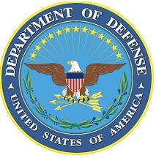DEPARTMENT OF THE AIR FORCE

HEADQUARTERS 107th ATTACK WING

NIAGARA FALLS NY

**ANNOUNCEMENT NAME:SPECIAL WARFARE/TACTIAL AIR CONTROL PARTY NF 26-02**

**OPENING DATE:** 01-OCT-25 **CLOSING DATE:** Open Estimated Boards Nov/May

**POSITION TITLE:** SPECIAL WARFARE/TACTIAL AIR CONTROL PARTY

**LOCATION:** 274th ASOS/Hancock Field Syracuse, New York

**1** POSITION AVAILABLE

**AUTH GRADE: O4**

**AFSC:** **I9ZXB**

**AREA OF CONSIDERATION:** Nationwide-New Commissioning and Cross Train

**TO APPLY EMAIL APPLICATIONS TO THE FOLLOWING:**

107FSS.Force.Management@us.af.mil

**SUBJECT LINE: SPECIAL WARFARE/TACTIAL AIR CONTROL PARTY NF 26-02**

**APPLICATION CONTENTS:**

Resume

AF Form 24

AFOQT

Full Physical Fitness Report

Official College Transcripts

**Without the required documentation, your package will not qualify for pre-screen. If you are qualified, Unit will contact you to schedule you for an interview. Incomplete packages will not be considered**.

**SELECTING OFFICIAL:** Lt Col Hansen