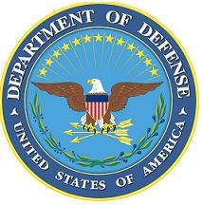DEPARTMENT OF THE AIR FORCE

HEADQUARTERS 107th ATTACK WING

NIAGARA FALLS NY

**ANNOUNCEMENT NAME: IG, DIRECTOR COMPAINTS AND RESOLUTION NF 23-03**

**OPENING DATE:** 02 OCT 2025 **CLOSING DATE:** 31-OCT 2025

**POSITION TITLE:** Director, Complaints and Resolution

**LOCATION:** 107th ATKW/Niagara Falls, New York

**1** POSITION AVAILABLE **DSG POSITION**

**AUTH GRADE:** CAPTAIN TO LIEUTENANT COLONEL

**AFSC:** **87Q0**

**AREA OF CONSIDERATION:** Nationwide

**TO APPLY EMAIL APPLICATIONS TO THE FOLLOWING:**

[107FSS.Force.Management@us.af.mil](mailto:107FSS.Force.Management@us.af.mil)

SUBJECT LINE: **IG, DIRECTOR COMPAINTS AND RESOLUTION NF 26-03**

**APPLICATION CONTENTS:**

* Recommendation Letter from Unit Commander
* No Unfavorable Information File or Open IG Investigations
* Must be a minimum grade of Captain
* Official Military Bio

**SELECTING OFFICIAL:** Lt Col Lindsay Doak