|  |  |
| --- | --- |
| **ENLISTED VACANCY ANNOUNCEMENT** | |
| **NEW YORK AIR NATIONAL GUARD 109TH AIRLIFT WING 1 AIR NATIONAL GUARD RD, SCOTIA, NY, 12302** | **ANNOUNCEMENT #: (E) FY 25-1** |
| **DATE: 16 September 2025** |
| **CLOSING DATE: UNTIL FILLED** |
| **UNIT:** 139 Aeromedical Evacuation Squadron | **AFSC: x**4N0X1  **RANK:** SSgt/TSgt |
| **POSITION TITLE:**  Aerospace Medical Service Craftsman – Flight and Operational Medical Technician | **AREA OF CONSIDERATION:** NATIONWIDE  All members who meet the qualifications for these positions. Anyone eligible to join the Air National Guard. |
| **SPECIALTY SUMMARY**  (As outlined in AFECD, 24 Apr 2025)  Plans, provides, and evaluates routine patient care and treatment of beneficiaries to include flying and special operational duty personnel. Organizes, coordinates, executes, and evaluates nursing activities in the medical environment as a Licensed Practical Nurse (LPN)/Licensed Vocational Nurse (LVN). Performs and directs support activities for patient care situations, including contingency operations and disasters. Performs duty as Flight and Operational Medical Technician…Subgroup 130000 | |
| **DUTIES AND RESPONSIBILITIES**  (As outlined in AFECD, 30 April 2025)  2.1. Provides, supervises, and manages patient care of beneficiaries to include flying and special operational duty personnel. Performs nursing tasks. Acts as Patient Centered Medical Home member or team leader. Front-line preventionist who identifies potential health risks and provides preventative counseling. Performs paraprofessional portions of preventative health assessments and physical examinations. Monitors and records physiological measurements. Orients patients to the hospital environment. Admits, discharges, and transfers patients as directed. Reports and records observations in patient progress notes and team conferences. Performs portions of medical treatment, diagnostic, and therapeutic procedures. Cares for, observes, and reports on pre/post-operative, seriously or critically ill, and injured patients. Records treatments and procedures rendered and observes effects. Performs postmortem care. Identifies patient problems and assists in developing and evaluating patient care plan(s). Assembles, operates, and maintains therapeutic equipment. Provides field medical care in contingency operations, disasters and austere environments. Performs basic life support, tactical combat casualty care (TCCC) and triage in emergency situations. Serves as member of primary emergency medical response to installation 911 Emergency Medical Services (EMS) response, in-flight emergencies, medical/trauma emergencies, and potential mass casualty scenarios for on- and off-base incidents. Operates emergency medical and other vehicles. Loads and unloads litter patients. Participates in contingency or disaster field training, exercises, and deployments. Augments search and rescue flying squadrons. Obtains and maintains linen and supplies/areas. Disposes of medical waste. Maintains inpatient and outpatient medical records. Screens medical records for deployability and other medical administrative requirements. Prepares and submits administrative reports. Manages supplies and equipment, submits, and executes budgets. Coordinates medical service activities with execution and clinical management teams. Utilizes the nursing process for promoting and maintaining patient health. Provides disease and disability education, care, and evaluation of nursing care. Participates in and leads the planning, implementation, and evaluation of nursing care. Performs assessment and analysis of patient health status, identifies health goals, recognizes subtle changes in conditions, interprets these changes, and immediately determines appropriate course of action. Participates in critical appraisal of pre-appraised evidence (such as clinical practice guidelines, evidencebased policies and procedures, and evidence syntheses). | |

HQ NYANG FM 11, 17 Sep 2019

|  |
| --- |
| **DUTIES AND RESPONSIBILITIES continued**  2.6.Performs Aeromedical Evacuation (AE) ground and/or flight duties as a non-career enlisted aviator. Performs pre- flight/inflight patient care and documentation. Provides emergency care for patients in event of medical and/or aircraft emergencies. Functions as an aeromedical evacuation crewmember (AECM). Prepares patients, equipment, and aircraft for flight. Enplanes and deplanes patients. Loads and unloads baggage. Operates specialized aircraft flight equipment, medical devices and aircraft systems related to patient care. Assist with mission planning, launch, and recovery. Performs continuous ground/flight training.  2.12 Performs paramedic duties in peacetime and contingency environments. Serves as subject matter expert in pre-hospital patient transport and care. Delivers and coordinates care between points of illness or injury, within transport echelons between far forward and fixed medical facilities, and until patient care is relinquished to another component within the continuum of care. Maintains thorough patient care documentation. Obtains information from persons involved or present at point of injury or illness, examines casualties, and determines nature, extent, or magnitude of illness or injury to establish treatment protocols to be followed or the need for additional assistance. Maintains proficiency in the use and routine management of transport equipment and methods including invasive airways, mechanical ventilators, perisurgical devices, medications, analgesia and sedation, and cardiovascular monitoring and support  3.1.1. 4N0X1/X. Medical terminology, anatomy and physiology; nursing theory, techniques and procedures; nursing assessment; team nursing; patient needs; emergency medical treatment to include cardiopulmonary resuscitation; aseptic technique; medical ethics and legal aspects; prescribed drugs/immunizations and their administration; population health concepts; operating and maintaining therapeutic equipment; transportation of sick and wounded; risk management; medical computer systems; resource management military hygiene and sanitation; fundamentals of primary care management (PCM); preventive medicine and counseling techniques; physical examinations and standards, contingency operations, disaster preparedness and chemical warfare; flight physiology fundamentals; maintenance of the human weapon system; and operational readiness of the war fighter.  3.1.6. ↔4N0X1G. Members in an X4N0X1G active flying aircrew billet are worldwide qualified on five different aircraft and operate clinically independent of a Military Treatment Facility while evacuating and transporting patients to higher echelons of care. Members in 4N0X1G billets perform Aeromedical Evacuation Controllers duties, Aeromedical Evacuation Air Advisor duties, and/or Command Manager duties. |
| **CLEARANCE**  Secret, as a minimum. |
| **INQUIRIES ABOUT POSITIONS**  **Capt Connie Anderson – DSN: 344-2681 / Comm: 518-344-2681 Email: connie.anderson.4@us.af.mil** |

HQ NYANG FM 11, 17 Sep 2019

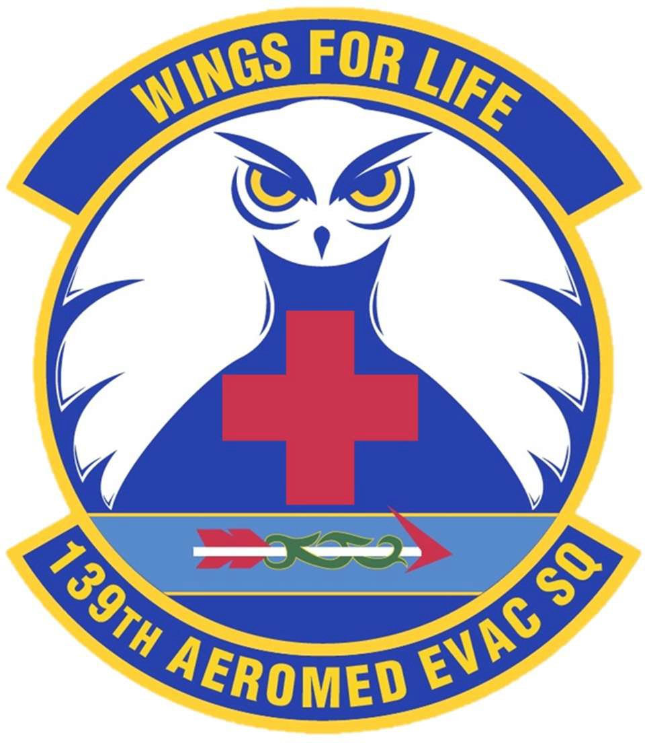

139th Aeromedical Evacuation Squadron Stratton Air National Guard Base, Schenectady NY

Road to Wings

aeRomedical evacuation technician

What is Aeromedical Evacuation?

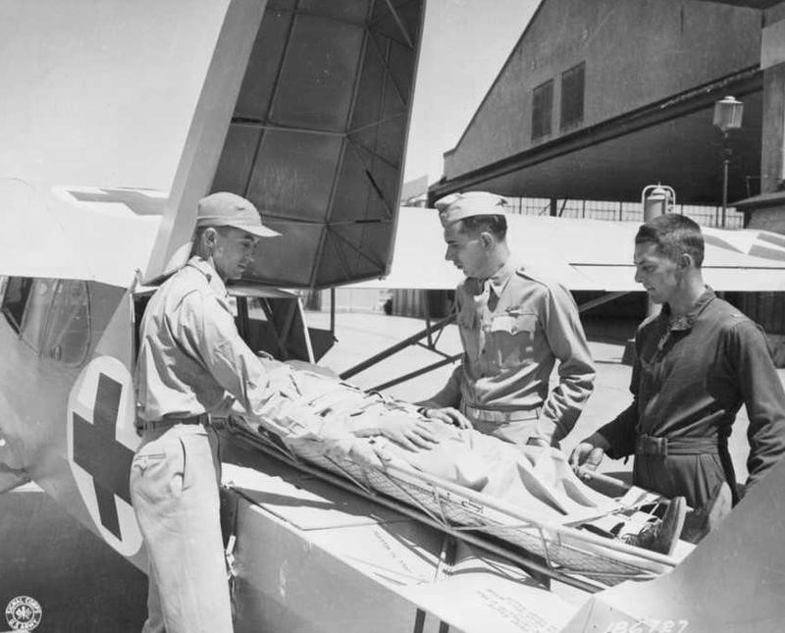The Air Force Aeromedical Evacuation (AE) system is a unique and significant part of the nation’s mobility resources. AE provides time-sensitive movement of casualties to and between medical treatment facilities, using Air Force and/or contracted aircraft with medical aircrew trained explicitly for the mission. AE forces can operate as far forward as aircraft are able to conduct air operations, across the full range of military operations, and in all operating environments. Specialty medical teams may be assigned to work with the AE aircrew to support patients requiring more intensive patient care.

The 139th Aeromedical Evacuation Squadron (139 AES) is one of nine Air National Guard Aeromedical Evacuation Squadrons (AES). AE personnel consist of Flight Nurses, Aeromedical Evacuation Technicians (Flight Medics), and a variety of operations and support personnel trained to manage patient movement operations, communications, logistics and administrative functions.

The history of AE starts as early as the Crimean War when the French moved patients with hot air balloons. The seed was planted and blossomed rapidly with advancements in flight. The United States began moving patients by air in WWI. Approximately 1.5 million patients were airlifted in WWII leading to unprecedented survival rates. The AE mission is an indispensable and demanding military asset that amplifies the capability of the United States military.

Today, a substantial part of the AE capability lies within the Air Force Reserves and Air National Guard who dedicate their time training in preparation for deployment for humanitarian and contingency response.

Military Obligation. *We do not “work” in the Air Force; we serve in the Air Force.*

As a member of the Air National Guard your commitment is to enter training within the first year, attend one drill per month, complete annual training periods, maintain flight currencies and basic readiness items, and meet individual medical standards. For more, read “America’s Air Force; A Profession of Arms” (July 2015).

Home Station Requirements:

* 12 Regularly Scheduled Drills (RSD) – one weekend a month (24 days per year)
  + *Exceptions usually no drill in July, one or two “super drills”*
* Maintain flight currency – minimum of one flight every 90 days
  + To maintain flight pay – minimum of two flight hours per month
* 15 Annual Training Days (AT) per year – in the form of training exercises, operational missions, off station training missions, local training events
* 40 hours per 24 months of direct patient care

Deployment Requirements:

* Scheduling and locations vary but estimate about once every 4 years for 180 days.

These requirements are the minimum expectation. AE is a more demanding commitment than most Air National Guard positions – especially when you are in a training status your first 1-2 years. If you are looking for a one weekend a month gig – this is not the job for you.

Flight Training Mission schedules are affected by aircraft availability, weather and availability of other crew members. A skilled and contributing Flight Medic requires excellent time management and a flexible character and lifestyle.

Training Requirement. *There are no shortcuts to any place worth going.*

Once enlisted or assigned to the 139 AES, your priority is to complete all the required training. From the date of your enlistment to fully mission qualified Aeromedical Evacuation Technician (Flight Medic) can *sometimes* take up to two years – you will need to be patient and flexible.

School dates for each school are always subject to availability and funding, meaning the timeline is different for everyone.

Schools' dates are not always consecutive - expect to be back and forth between schools. If you are pursuing a demanding job or academic program, this may not be the best time for you to join.

Prior to entering the training pipeline, you must have completed a Class 3 Flight Physical and pass an Air Force Physical Fitness Test (AFPT). You should be prepared to take and pass the AFPT within three months of your enlistment date.



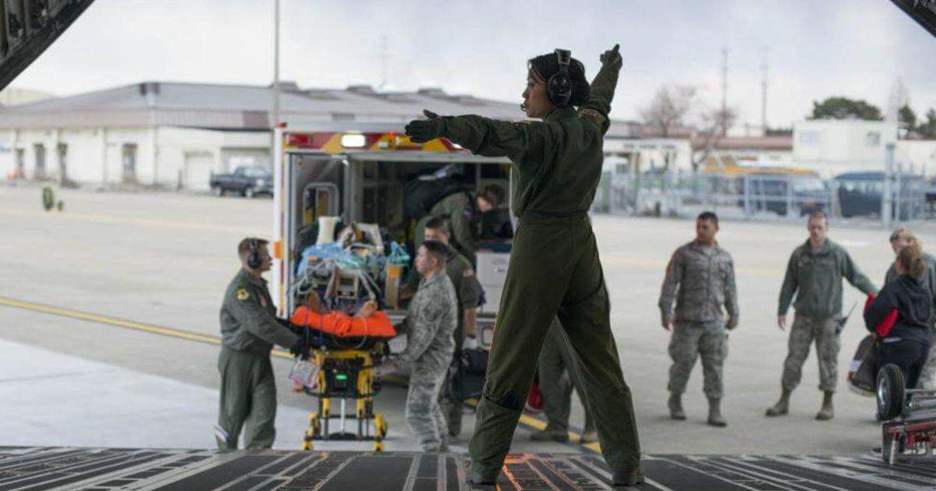

Flight Medics should plan to participate in flight and ground training as often as possible during the first six months following initial qualification. Ideally, new Flight Medics should plan to fly a minimum of once a month during the first 1-6 months, and then as often as possible in the following 6-12 months.

# Flight Medic Training Pipeline

**Basic Military Training (BMT)** Location: Lackland AFB, TX Length: 8 Weeks

## 4N0 Technical Training Phase 1

Location: Fort Sam Houston, TX Length: 16 Weeks

## 4N0 Technical Training Phase 2

Location: Variable Length: 6 Weeks

## 4N0 Technical Training Phase 3

Location: Variable Length: 4-6 Weeks

## Flight Nurse/Aeromedical Evacuation Technician (FNAET)

Location: Wright-Patterson AFB, OH Length: 5 Weeks

## AE Initial Qualification Formal Training Unit (AEIQ)

Location: Wright-Patterson AFB, OH Length: 5 Weeks

## Water Survival/Emergency Parachute

Location: Fairchild AFB, WA Length: 2 Days

## Survival, Evasion, Resistance, Escape (SERE)

Location: Fairchild AFB, WA Length: 10 Days

**Mission Qualification Training** Location: Home Station Length: 2-6 Months

Benefits & Contact Information

As a member of the Air National Guard, you can service your country and community in a unit close to home. You will also have access to military, state and federal benefits:

Benefits:

* 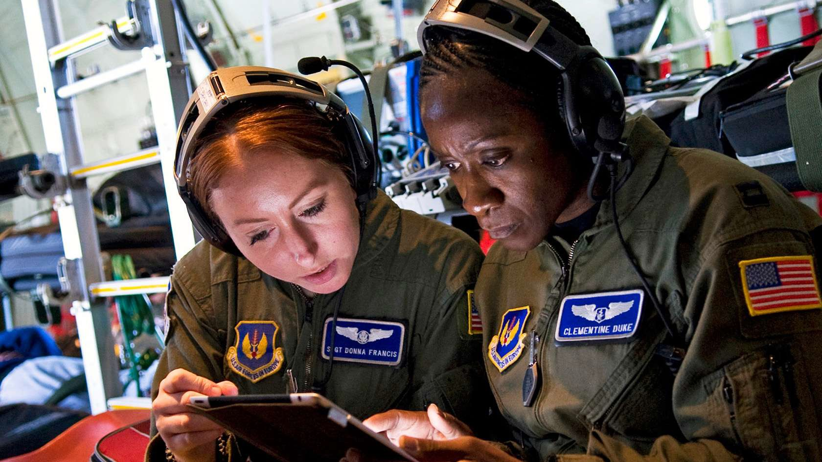Serve your country and community
* Global travel opportunities
* Leadership development
* Autonomous practice
* Specialized training
* Educational and tax benefits
* Low-cost health insurance
* Military retirement plan
* VA Home Loan & US Citizenship eligibility
* Occasional sign on or retention bonus
* Supplemental income
* Build relationships that last a lifetime

Additional Information: https://[www.youtube.com/watch?v=yAqo2zNz5s8&list=PLjZy4fJwp5HAzj2UGb24ok88RVT5KBGa_](http://www.youtube.com/watch?v=yAqo2zNz5s8&list=PLjZy4fJwp5HAzj2UGb24ok88RVT5KBGa_) https://[www.youtube.com/watch?v=gslNC8CiwEk](http://www.youtube.com/watch?v=gslNC8CiwEk)

https://youtu.be/9UaQs_mocSA https://[www.youtube.com/watch?v=5QZFbS81kEU](http://www.youtube.com/watch?v=5QZFbS81kEU)

https://[www.dvidshub.net/news/417497/139-air-evacuation-squadron-attends-arctic-eagle-patriot-22](http://www.dvidshub.net/news/417497/139-air-evacuation-squadron-attends-arctic-eagle-patriot-22) https://[www.facebook.com/109thaw](http://www.facebook.com/109thaw)

139th Aeromedical Evacuation Squadron

For more information on the expectations of being a Flight Medic, you may contact the unit directly at 518-344-2681 or [109.aw.139.aes.fulltime@us.af.mil.](mailto:109.aw.139.aes.fulltime@us.af.mil) You can ask to speak to any of the full time Flight Medics, Flight Nurses, or Unit Training Manager.

109th Airlift Wing Recruiting Office

For more information on submitting a Flight Nurse application, you may contact the recruiting office at 518-344-2200 or [109.aw.recruiting@us.af.mil](mailto:109.aw.recruiting@us.af.mil)

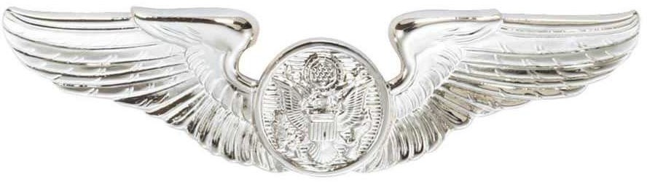

CAO May 2024