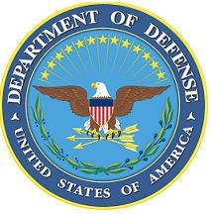DEPARTMENT OF THE AIR FORCE

HEADQUARTERS 107th ATTACK WING

NIAGARA FALLS NY

**ANNOUNCEMENT NAME: HUMAN RESOURCES & ADMINISTRATION NF 26-07**

**OPENING DATE:** 17-OCT-25 **CLOSING DATE:** 6 NOV 25

**POSITION TITLE:** **HUMAN RESOURCES & ADMINISTRATION**

**LOCATION:** 107th ATKW Niagara Falls, New York

**1** POSITION AVAILABLE

**AUTH GRADE: E7**

E6 must be immediately promotable to E7

**AFSC:3F071/3F571**

**AREA OF CONSIDERATION:** WING

**TO APPLY EMAIL APPLICATIONS TO THE FOLLOWING:**

107FSS.Force.Management@us.af.mil

**SUBJECT LINE: HUMAN RESOURCES & ADMINISTRATION NF 26-07**

**APPLICATION CONTENTS:**

CURRENT PT

RIP

SUPERVISOR RECOMMENDATION LETTER

**SELECTING OFFICIAL:** CMSgt Mott