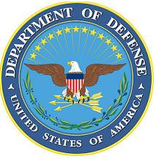
DEPARTMENT OF THE AIR FORCE

HEADQUARTERS 107th ATTACK WING
NIAGARA FALLS NY

ANNOUNCEMENT NAME: SECURITY FORCES COMMANDER NF 26-08

OPENING DATE: 27-Oct-2025 CLOSING DATE: 11-Jan-2026

POSITION TITLE: SECURITY FORCES COMMANDER

LOCATION: 107th ATKW Niagara Falls, New York

1 POSITION AVAILABLE

AUTH GRADE: Min O-1/Lt; Max O-5 / LtCol DSG POSITION
AFSC: 31P

AREA OF CONSIDERATION: Nationwide

TO APPLY EMAIL APPLICATIONS TO THE FOLLOWING:
107FSS.Force.Management@us.af.mil
SUBJECT LINE: SECURITY FORCES COMMANDER NF 26-08

APPLICATION CONTENTS:

Required attachments: AF Form 24, Current PT, Civilian Resume, Military Resume, Military Bio, RIP

SELECTING OFFICIAL: Col. William Gourlay

