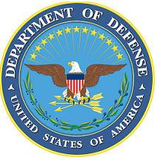
DEPARTMENT OF THE AIR FORCE

HEADQUARTERS 107th ATTACK WING
NIAGARA FALLS NY

ANNOUNCEMENT NAME: SUPERINTENDENT, INSPECTOR GENERAL NF 26-09

OPENING DATE: 01-DEC-25 CLOSING DATE: 31-JAN-26

POSITION TITLE: Superintendent, Inspector General

LOCATION: 107th ATKW Niagara Falls, New York

1 POSITION AVAILABLE

AUTH GRADE: E8

AFSC: 8I000

AREA OF CONSIDERATION: NATIONWIDE

TO APPLY EMAIL APPLICATIONS TO THE FOLLOWING:
107FSS.Force.Management@us.af.mil
SUBJECT LINE: INSPECTIONS COORDINATOR NF 26-09

APPLICATION CONTENTS:
Letter of Recommendation from Commander
Official Military Bio
Must be a minimum grade of E7 and possess a 7-level AFSC
No UIF, civil convictions or an open IG investigation

SELECTING OFFICIAL: Lt Col Lindsay Doak

