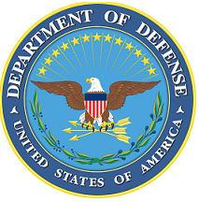
DEPARTMENT OF THE AIR FORCE

HEADQUARTERS 107th ATTACK WING
NIAGARA FALLS NY

ANNOUNCEMENT NAME: FIRST SERGEANT NF 26-11

OPENING DATE: 01-JAN-26 CLOSING DATE: 8-FEB-26

POSITION TITLE: First Sergeant

LOCATION: 274th ASOS Syracuse, New York

1 POSITION AVAILABLE

AUTH GRADE: E7
Must be a minimum grade of E6 immediately promotable to E7
AFSC: 8F000

AREA OF CONSIDERATION: NATIONWIDE

TO APPLY EMAIL APPLICATIONS TO THE FOLLOWING:
107FSS.Force.Management@us.af.mil
SUBJECT LINE: FIRST SERGEANT NF 26-11

APPLICATION CONTENTS:
Official Military Bio
RIP
Current PT
No UIF, civil convictions or an open IG investigation

SELECTING OFFICIAL: LtCol Jeffrey Hansen

