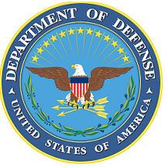
DEPARTMENT OF THE AIR FORCE

HEADQUARTERS 107th ATTACK WING
NIAGARA FALLS NY

ANNOUNCEMENT NAME: Command Post Superintendent NF 26-13

OPENING DATE: 1 April 2026 CLOSING DATE: 1 May 2026

POSITION TITLE: Command Post Superintendent

LOCATION: 107th ATKW NIAGARA FALLS IAP, NIAGARA FALLS, NY 14304

1 POSITION AVAILABLE

AUTH GRADE: E8 Immediately promotable is not a requirement

AFSC: 1C3X1

AREA OF CONSIDERATION: Nationwide

TO APPLY EMAIL APPLICATIONS TO THE FOLLOWING:
107FSS.Force.Management@us.af.mil
SUBJECT LINE: Command Post Superintendent NF 26-13
Please provide as one PDF.

APPLICATION CONTENTS:
Min Grade E7
vMPF Records Review (RIP)
Complete Fitness Report
Limit Letters of Recommendation to no more than two

SELECTING OFFICIAL: Col Steven Hefferon

