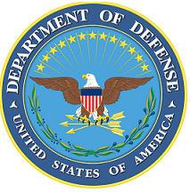
DEPARTMENT OF THE AIR FORCE

HEADQUARTERS 107th ATTACK WING
NIAGARA FALLS NY

ANNOUNCEMENT NAME: Force Support Officer NF 26-14

OPENING DATE: 22 April 2026 CLOSING DATE: 15 June 2026

POSITION TITLE: Force Support Officer

LOCATION: 107th ATKW NIAGARA FALLS IAP, NIAGARA FALLS, NY 14304

1 POSITION AVAILABLE

AUTH GRADE: O4 Existing Officer & New Commissioning Opportunity

AFSC: 38F

AREA OF CONSIDERATION: Nationwide

TO APPLY EMAIL APPLICATIONS TO THE FOLLOWING:
107FSS.Force.Management@us.af.mil
SUBJECT LINE: Force Support OfficerNF 26-14
Please provide as one PDF.

APPLICATION CONTENTS:
Existing Officer & New Commissioning Opportunity
vMPF Records Review (RIP)
Complete Fitness Report
Official College Transcripts
Limit Letters of Recommendation to no more than two
AF Form 22
Must have AFOQT prior to application
Degree must be completed prior to June 30th 2026

SELECTING OFFICIAL: LtCol Daniel Bond

