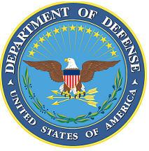
DEPARTMENT OF THE AIR FORCE

HEADQUARTERS 107th ATTACK WING
NIAGARA FALLS NY

ANNOUNCEMENT NAME: Warfighter Communications Career Enlisted Manager NF 26-15

OPENING DATE: 04-JUN-26 CLOSING DATE: 4-JUL-26

POSITION TITLE: Warfighter Communications Career Enlisted Manager

LOCATION: 107th ATKW Niagara Falls, New York

1 POSITION AVAILABLE

AUTH GRADE: E9

AFSC: 1D700

AREA OF CONSIDERATION: UNIT

TO APPLY EMAIL APPLICATIONS TO THE FOLLOWING:
107FSS.Force.Management@us.af.mil
SUBJECT LINE: Warfighter Communications Career Enlisted Manager NF 26-15
APPLICATION CONTENTS:
MUST HOLD 1D7 AFSC
REQUIRED PME COMPLETE
RIP

SELECTING OFFICIAL: Lt Col Randy P. Allen

